Assessment Schedule – 2012 Physics: Demonstrate understanding of mechanics (91171)
Question | Achievement |  |  |  |  |  | Merit |  |  | Excellence
ONE  (a) | Energy
(b) | Momentum
(c) | 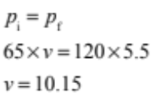 |  |  |  |  |  | 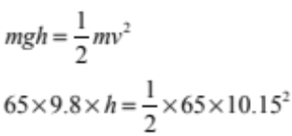 |  |  | h = 5.3 m
(d) | Arrow towards centre of circle.
(e) | Hannah is moving in a circle so there must be a centripetal force on her.  OR  The centripetal force is provided by the rope (tension). |  |  |  |  |  | Hannah is moving in a circle so there must be a centripetal force on her.  AND  The centripetal force is provided by the rope(tension). |  |  | At the lowest point of her swing, the unbalanced force, the centripetal force, is the difference between the tension force acting upwards and the gravity force acting vertically down. It is this unbalanced force that causes her to move in a circle.
NØ |  | N1 | N2 | A3 | A4 | M5 |  | M6 | E7 |  | E8
No evidence |  | 1a | 2a | 3a | 4a | 1a + 2m |  | 2a + 2m | 1a + 2e |  | 2a + 2e

TWO  (a) | 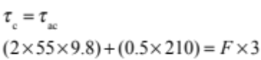 |  |  |  | 1183 = F × 3  F = 394.3 = 394 N |  |  | F= 394 N  Direction = up
(b) | 390 ( 2 sig figs)  AND  Same as the least accurate data.
(c) | 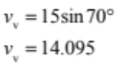 |  |  |  | 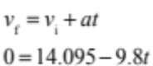  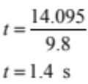
(d) | Horizontal velocity is 5.1 m s^{–1} to the right.  OR  Her vertical velocity is zero. |  |  |  | Horizontal velocity is 5.1 m s^{–1} to the right.  AND  Her vertical velocity is zero.  OR  One reason to support either  5.1 m s^{–1} or 0 m s^{–1}. |  |  | Horizontal velocity is 5.1 m s^{–1} to the right.  AND  Her vertical velocity is zero.  AND  There is no horizontal force acting on her, so her horizontal velocity is constant.  OR  She is constantly being accelerated at 9.8m s^{–2} downwards. hence her vertical velocity at the top is 0 m s^{–1}.
NØ |  | N1 | N2 | A3 | A4 | M5 | M6 |  | E7 | E8
No evidence |  | 1a | 2a | 3a | 4a | 1a + 2m | 2a + 2m |  | 2m + 1e | 1m + 2e

THREE  (a) | Gravitational PE → Kinetic energy  OR  Kinetic energy → Elastic PE |  |  |  | Gravitational PE → Kinetic energy  AND  Kinetic energy →Elastic PE
(b)(i) | The force is upwards.
(b)(ii) | If the rope is too tight, this will decrease her stopping time.  OR  The size of force increases.  OR  The size of her deceleration increases. |  |  |  | If the rope is too tight this will decrease her stopping time and so increase the size of the force acting on her.  OR  A shorter stopping time will increase the size of her deceleration. |  |  | If the rope is too tight this will decrease her stopping time.  AND  Δp = FΔt, the rope tension does not affect Δp.  So a shorter stopping time will increase the size of the upward force acting on her.  OR  A shorter stopping time will increase the size of her deceleration. F = ma and m is constant. So, a larger deceleration requires a larger upward force on her.
(c) | F = mg and F = kx  55 × 9.8 = k × 0.60 |  |  |  | k = 898.3 |  |  | 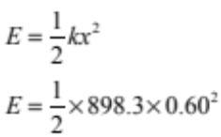  E = 160 J
NØ |  | N1 | N2 | A3 | A4 | M5 | M6 |  | E7 | E8
No evidence |  | 1a | 2a | 3a | 4a | 1a + 2m | 3m  or 2m +2a |  | 2m + 1e  Or 1a + 2e | 1m + 2e

FOUR  (a) | 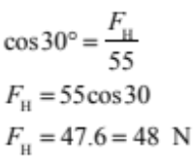
(b) (i) | If the trolley is in equilibrium the net force is zero.  OR  Forces are balanced.  OR  Net torque is zero.  OR  Velocity is constant. |  |  |  | If the trolley is in equilibrium the net force is zero OR Forces are balanced.  AND  Net torque is zero. |  |  |  | If the trolley is in equilibrium the net force is zero OR Forces are balanced.  AND  Net torque is zero.  AND  This means that velocity is constant or acceleration is zero (NOT v =0 ).
b(ii) | Force to the right labelled Friction or traction OR Grip OR Thrust.  OR  Force to the left labelled push force OR similar. |  |  |  | Force to the right labelled Friction or traction OR Grip OR Thrust.  AND  Force to the left labelled push force OR similar.
(c) | By decreasing the angle between the handle and the floor. |  |  |  | By decreasing the angle between the handle and the floor.  AND  This increases the horizontal force. |  |  |  | By decreasing the angle between the handle and the floor.  AND  This increases the horizontal force causing the horizontal force to become unbalanced.  AND  This will result in acceleration. {(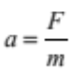) and m is constant}.
NØ |  | N1 | N2 | A3 |  | A4 | M5 | M6 |  | E7 | E8
No evidence |  | 1 a | 2a | 3a |  | 4a | 3a + 1m | 2a + 2m |  | 2m+1e  Or 1a + 2e | 1m +2e

Judgement Statement
 | Not Achieved | Achievement | Achievement  with Merit | Achievement  with Excellence
Score range | 0 – 8 | 9 – 17 | 18 – 24 | 25 – 32

